RESEARCH PROPOSAL

Name of the Proponents: _Manguiat, Paul Albert_
_Rosario, Recca Morelle_

School Year: _2021 - 2022_

Proposed Title: _Komyut.ph – A Philippine Commuter’s Guide_

Area of Investigation: General Philippine Commuting Areas
Methodology: Web Development, Application Developement
Programming language to be used: Java, Javascript
Target Users and Beneficiaries: Public Commuters in the Philippines

Beneficiary of equipment provided/purchased:
Computer Science Department



Proponents:

________________________ __ ______________________
Paul Albert M. Manguiat Recca Morelle Rosario

Approved by:

Dr. Myra San Juan Santos, MSCS, MACoed, DIT
College Dean – CS

Prof. Ramcel Gamboa
Adviser

Objective of the Study
General Objective of the Study
The goal of the study is to ensure that the Komyut.ph will be useful for Philippine commuters and would provide the determined services as to how the website’s/application's feature was to be programmed. It will be done through maintenance of the service for the benefit the users via providing an accurate way of transportation through the use of their digital devices without any hassle.

Specific objective of the study
1. To create a app/website that can Provide commuting routes through the use of Komyut.ph route search function.
2. To create a app/website that can Ensure accuracy of all routes presented to ensure user’s confidence while commuting.
3. To create a app/website that can Provide all possible PUV routes to a destination so users can choose which one suits their budget, situation, etc.
4. To create an app/website that can fulfill the above purpose so as to minimize the need for interacting with strangers especially for introvert persons.
5. To create an app/website that can provide each route, total costs so users will have an idea on what their commuting budget will be.

Statement of the Problem
General statement of the Problem
As many travelers in the Philippines rely on public transport to go places, there are cases of people struggling to find the right public transport to go to their destination This people include: first time commuters, including those that are travelling to unfamiliar destinations for the first time, people who want to find an alternate route or a different mode of transportation to their destinations for several reasons like traffic congestion, financial issues, etc., and people who got lost in the middle of their commute due to certain factors (i.e. commuters that got off a PUV at the wrong destination).
People in these situations will tend to search the internet or may ask a local or passerby for help on what jeepneys or bus to ride to get to their correct destination. While Filipinos are generally helpful in these kinds of situations, there are times where instructions are not clear or unintentionally inaccurate. And there are destinations where finding a guide on the internet is difficult, if not non-existent.

Specific statement of the Problem
1. First-time solo commuters often have no prior idea of how to and what PUVs to ride to go to their destinations.
2. People who have to commute to unfamiliar places often get lost on their way due to getting off at wrong stops or wrong route information gathered.
3. There are commuters who often want to find alternative PUV routes to their routine commutes due to traffic congestions on the routes they are using, finding their current commuting spending too expensive, or other reasons.
4. Commuters often find it hard to ask strangers or have to shore up courage to be able to ask for commuting directions while on the road.
5. There are cases of people wanting to find out how much they will be spending on a commute beforehand to prepare their budget.

Significance of the Study
Komyut.ph will mainly be benefitting public commuters as the system is designed to provide all possible commuting routes to their destinations in an accurate manner. It is specifically designed for people commuting to areas they are not familiar with, first time commuters, and people who want to find alternative routes to their everyday commute. As an aside, it will also be benefitting PUV drivers and operators since the system will be promoting public modes of transportations.

Scope and Limitation of the Study
While Komyut.ph is envisioned as a countrywide public commuter’s guide, for the course of this research the study will be limited primarily to public transport commuters in Rizal Province while also including public travelers in the Greater Manila Area.
On the system side of things, Komyut.ph database will primarily include public route data in the Rizal-Metro Manila area. However, given time and resource availability, data will be expanded to include more areas including, but not limited to, the provinces of Batangas, Laguna, etc.
Search - Komyut.ph has a Search function wherein users will input where they will be coming from and where they are going to in their respective input boxes. Upon hitting the search button, the website or app will show all different commuting routes available. Each route is presented in a step-by-step style, if the commute will require riding multiple PUVs. Users can also declare if they want to search as a senior citizen or student so the results will show the fares at a discounted rate for students or seniors.
Suggest - The website/app also has a Suggest function wherein users can share commuting routes that is not yet on the system’s database. Users can either suggest through filling up the suggest for or by uploading a video of the route of concern. Once the administrators of the system verified the existence of the route, it will be added to the system’s database so future searches on the said route will now include the confirmed suggested route in the search results.

Limitation
In terms of back-end database concerning the commuting routes to be included, the system will be initially limited to routes within the Rizal-Metro Manila Area. In the event of time and resource availability, the route area may be extended to include routes in other areas starting from the Laguna area outwards. Komyut.ph will include average commute time of watch route. However, since most Philippine public vehicles realistically doesn’t follow an exact schedule of arrival at a specific destination. Exact times of when a PUV will arrive at the starting point of travel up until the destination area will not be included in the system. In connection to this, the user will not be asked what time they will start their commute.
In terms of accessibility, since the website/app is visual-centric, and the proponents have little-to-no knowledge of implementations of text-to-speech or speech-to-text technology, people with total vision impairment will not be included as target users of the system.
In terms of visual features, maps will not be included in the system. The system relies on accurate route guidance with fast search results. As such the system is designed so that every web pages of search results will be loaded on the user’s screens as fast as possible. The inclusion of maps is estimated to slow down page loading from 30 seconds to 1 minute on a 110 Mbps-speed broadband internet in the Philippines based on map loading times gathered from google maps on the proponents’ computers and smartphones.

The Proposed System
System Overview
Komyut.ph is a website/application wherein users can search guides on how to commute to a certain destination. On the home screen, users will input where they will start their commute and where is their destination. Based on those two inputs, the system will began searching the database for all routes that meet the conditions that the user searched for.
The results will appear as a table showing the start point, what vehicle to ride and what route to take, the destination, and the cost. In cases when searched routes require the user to ride two of more vehicles, each vehicle will be presented by rows. So that, for instance, if a commute will require two vehicles, the first row will show the starting point, vehicle to ride, and the place where the user needs to get off to transfer to the next vehicle. The second row will the show the place where user will transfer, next vehicle to ride, and the destination typed in by the user.
The results screen will also show the cost for the trips in each result, and average time of travel. If the route the user wants to find is not yet in the database, the screen will display that such commuting route is not found, which will also include a link to the suggest page.
The suggest page, as its name suggest, allows users to send any commuting routes that exists but is not found in the system’s database. Users will fill out a form to describe the details of the route they want to suggest. Alternatively, users can send a video of the commute route they want to suggest.
The system uses two databases for its operation. The first one, the route database, are where information about different route information will be stored and will be accessed by the system to show to the users depending on what the users searched for. The second is the suggestions database. This is where user submitted route submissions will be stored. The route database will be updated by the system admins with information gathered from surveying different routes across the country and by information from the suggestions database that were authenticated for correctness.

Data Flow Diagram
Level 0
Search/Suggest route info
Update Route Database
Commuter
Komyut.ph
Website/App
System
Admin

Receive search results

Level 1
Suggest a route
Commuter
System Admin

Route Database
Confirm Authenticity
Search for commuting route

Confirmed Route Authenticity
Komyut.ph Website/App
System Admin

Encode Route
Komyut.ph Website/App
Route Database

Look up for results based on user’s input
Display Results
Route Database

Commuter

Prototype
In this section are the screenshots of the prototype version for the website and smartphone application of Komyut.ph.

Screen Output
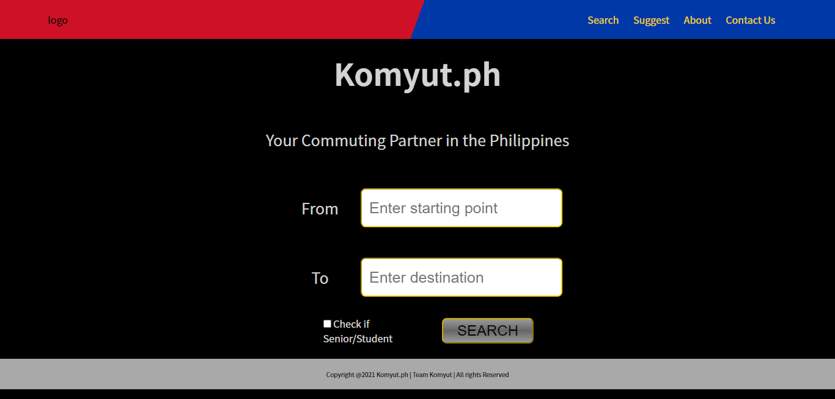

Systems Implementation
In this section, the recommended software and hardware requirements needed in order to be able to run the Komyut.ph website on computers and the Komyut.ph application on smartphones will be discussed. Aside from the requirements below, internet connection is required to access the Komyut.ph system.
Hardware Requirements
Personal Computers/ Laptops | Processor | Pentium 4 or higher
Personal Computers/ Laptops | RAM | 256 MB
Personal Computers/ Laptops | Disk Space | 200 MB
Smartphones | Phones that have the ability to support google play and apple store applications or can support web browsers.

Software Requirements
Personal Computers/ Laptops | Operating System | Windows XP SP2 or later  Mac OS X 10.5 or later  Ubuntu 10.04  Debian 6  OpenSUSE 11.3  Fedora Linux 14
Personal Computers/ Laptops | Web Browsers | Internet Explorer 8 or higher  Microsoft Edge  Google Chrome  Safari  Opera  Mozilla Firefox
Smartphones | App Store | Google Play  Apple Store
Smartphones | Browsers | Built-in browsers  Google Chrome  Safari  Opera

